PROG POE PART 1 SCREENSHOTS:

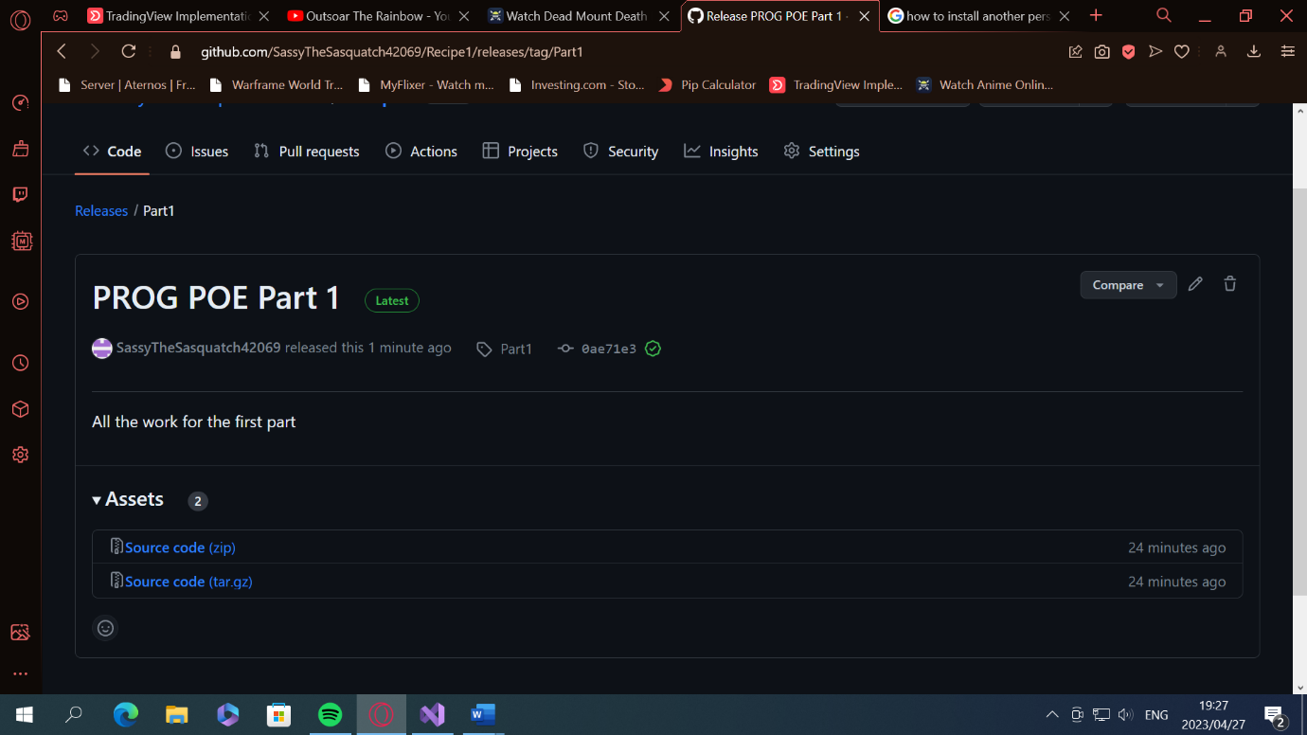

https://github.com/SassyTheSasquatch42069/Recipe1